http://blog.csdn.net/astrotycoon/article/details/45315437

引出问题
在嵌入式应用程序开发过程中，调试一直是个老大难问题 -- 由于环境的限制，当程序发生段错误时不能很好的定位到底是哪里出现了错误，如果在程序发生段错误时能够清晰明了地看到程序的栈帧链，那无疑是雪中送炭。本文就捕捉信号SIGSEGV并在该信号的处理函数中打印出函数栈帧链来帮助我们调试程序。
本文的程序适合ARM和X86平台。

回溯栈帧原理
理解函数栈帧的布局后，那么自然明白回溯栈帧的原理了，这里不多解释了，直接上图（来自网络）：
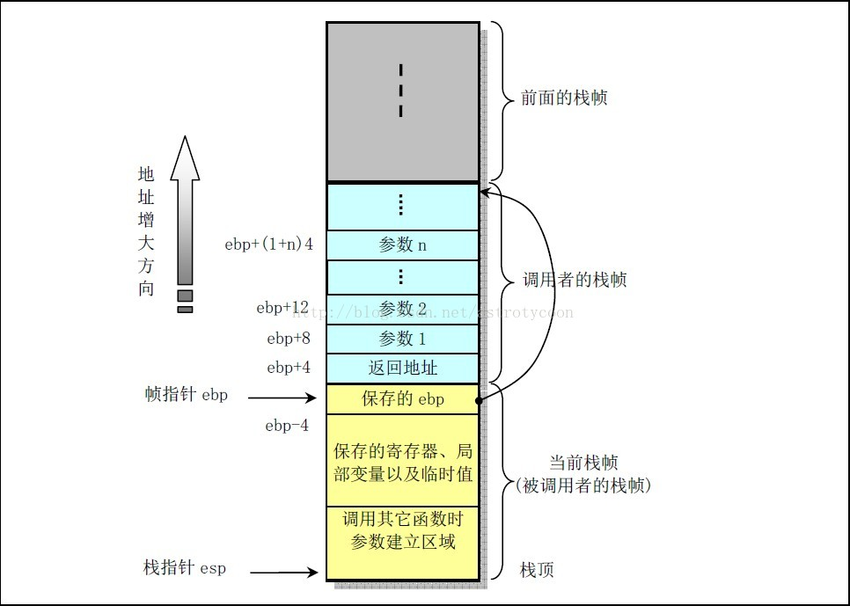
x86函数栈帧结构
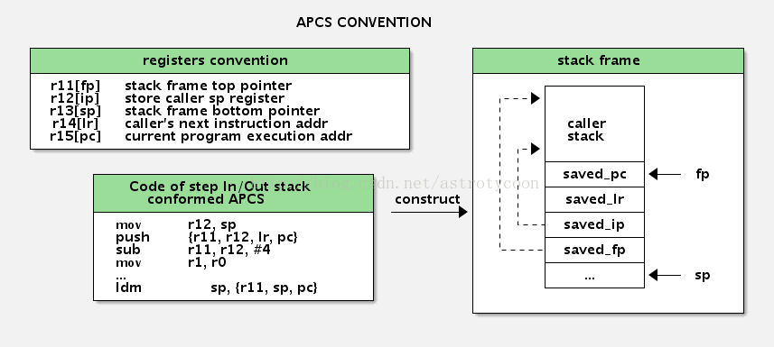
ARM函数栈帧结构
#ifndef _GNU_SOURCE
#define _GNU_SOURCE
#endif
#include <stdio.h>
#include <dlfcn.h>
#include <stdlib.h>
#include <signal.h>
#include <unistd.h>
#include <string.h>
#include <ucontext.h>

/* 纯C环境下，不定义宏NO_CPP_DEMANGLE */
#if (!defined(__cplusplus)) && (!defined(NO_CPP_DEMANGLE))
#define NO_CPP_DEMANGLE
#endif

#ifndef NO_CPP_DEMANGLE
#include <cxxabi.h>
#ifdef __cplusplus
using __cxxabiv1::__cxa_demangle;
#endif
#endif

#ifdef HAS_ULSLIB
#include <uls/logger.h>
#define sigsegv_outp(x) sigsegv_outp(, gx)
#else
#define sigsegv_outp(x, ...) fprintf(stderr, x"\n", ##__VA_ARGS__)
#endif

#if (defined __x86_64__)
#define REGFORMAT "%016lx"
#elif (defined __i386__)
#define REGFORMAT "%08x"
#elif (defined __arm__)
#define REGFORMAT "%lx"
#endif

static void print_reg(ucontext_t *uc)
{
#if (defined __x86_64__) || (defined __i386__)
int i;
for (i = 0; i < NGREG; i++) {
sigsegv_outp("reg[%02d]: 0x"REGFORMAT, i, uc->uc_mcontext.gregs[i]);
}
#elif (defined __arm__)
sigsegv_outp("reg[%02d] = 0x"REGFORMAT, 0, uc->uc_mcontext.arm_r0);
sigsegv_outp("reg[%02d] = 0x"REGFORMAT, 1, uc->uc_mcontext.arm_r1);
sigsegv_outp("reg[%02d] = 0x"REGFORMAT, 2, uc->uc_mcontext.arm_r2);
sigsegv_outp("reg[%02d] = 0x"REGFORMAT, 3, uc->uc_mcontext.arm_r3);
sigsegv_outp("reg[%02d] = 0x"REGFORMAT, 4, uc->uc_mcontext.arm_r4);
sigsegv_outp("reg[%02d] = 0x"REGFORMAT, 5, uc->uc_mcontext.arm_r5);
sigsegv_outp("reg[%02d] = 0x"REGFORMAT, 6, uc->uc_mcontext.arm_r6);
sigsegv_outp("reg[%02d] = 0x"REGFORMAT, 7, uc->uc_mcontext.arm_r7);
sigsegv_outp("reg[%02d] = 0x"REGFORMAT, 8, uc->uc_mcontext.arm_r8);
sigsegv_outp("reg[%02d] = 0x"REGFORMAT, 9, uc->uc_mcontext.arm_r9);
sigsegv_outp("reg[%02d] = 0x"REGFORMAT, 10, uc->uc_mcontext.arm_r10);
sigsegv_outp("FP = 0x"REGFORMAT, uc->uc_mcontext.arm_fp);
sigsegv_outp("IP = 0x"REGFORMAT, uc->uc_mcontext.arm_ip);
sigsegv_outp("SP = 0x"REGFORMAT, uc->uc_mcontext.arm_sp);
sigsegv_outp("LR = 0x"REGFORMAT, uc->uc_mcontext.arm_lr);
sigsegv_outp("PC = 0x"REGFORMAT, uc->uc_mcontext.arm_pc);
sigsegv_outp("CPSR = 0x"REGFORMAT, uc->uc_mcontext.arm_cpsr);
sigsegv_outp("Fault Address = 0x"REGFORMAT, uc->uc_mcontext.fault_address);
sigsegv_outp("Trap no = 0x"REGFORMAT, uc->uc_mcontext.trap_no);
sigsegv_outp("Err Code = 0x"REGFORMAT, uc->uc_mcontext.error_code);
sigsegv_outp("Old Mask = 0x"REGFORMAT, uc->uc_mcontext.oldmask);
#endif
}

static void print_call_link(ucontext_t *uc)
{
int i = 0;
void **frame_pointer = (void **)NULL;
void *return_address = NULL;
Dl_info dl_info = { 0 };

#if (defined __i386__)
frame_pointer = (void **)uc->uc_mcontext.gregs[REG_EBP];
return_address = (void *)uc->uc_mcontext.gregs[REG_EIP];
#elif (defined __x86_64__)
frame_pointer = (void **)uc->uc_mcontext.gregs[REG_RBP];
return_address = (void *)uc->uc_mcontext.gregs[REG_RIP];
#elif (defined __arm__)
/* sigcontext_t on ARM:
unsigned long trap_no;
unsigned long error_code;
unsigned long oldmask;
unsigned long arm_r0;
...
unsigned long arm_r10;
unsigned long arm_fp;
unsigned long arm_ip;
unsigned long arm_sp;
unsigned long arm_lr;
unsigned long arm_pc;
unsigned long arm_cpsr;
unsigned long fault_address;
*/
frame_pointer = (void **)uc->uc_mcontext.arm_fp;
return_address = (void *)uc->uc_mcontext.arm_pc;
#endif

sigsegv_outp("\nStack trace:");
while (frame_pointer && return_address) {
if (!dladdr(return_address, &dl_info)) break;
const char *sname = dl_info.dli_sname;
#ifndef NO_CPP_DEMANGLE
int status;
char *tmp = __cxa_demangle(sname, NULL, 0, &status);
if (status == 0 && tmp) {
sname = tmp;
}
#endif
/* No: return address <sym-name + offset> (filename) */
sigsegv_outp("%02d: %p <%s + %lu> (%s)", ++i, return_address, sname,
(unsigned long)return_address - (unsigned long)dl_info.dli_saddr,
dl_info.dli_fname);
#ifndef NO_CPP_DEMANGLE
if (tmp) free(tmp);
#endif
if (dl_info.dli_sname && !strcmp(dl_info.dli_sname, "main")) {
break;
}

#if (defined __x86_64__) || (defined __i386__)
return_address = frame_pointer[1];
frame_pointer = frame_pointer[0];
#elif (defined __arm__)
return_address = frame_pointer[-1];
frame_pointer = (void **)frame_pointer[-3];
#endif
}
sigsegv_outp("Stack trace end.");
}

static void sigsegv_handler(int signo, siginfo_t *info, void *context)
{
if (context) {
ucontext_t *uc = (ucontext_t *)context;

sigsegv_outp("Segmentation Fault!");
sigsegv_outp("info.si_signo = %d", signo);
sigsegv_outp("info.si_errno = %d", info->si_errno);
sigsegv_outp("info.si_code = %d (%s)", info->si_code,
(info->si_code == SEGV_MAPERR) ? "SEGV_MAPERR" : "SEGV_ACCERR");
sigsegv_outp("info.si_addr = %p\n", info->si_addr);

print_reg(uc);
print_call_link(uc);
}

_exit(0);
}

#define SETSIG(sa, sig, fun, flags) \
do { \
sa.sa_sigaction = fun; \
sa.sa_flags = flags; \
sigemptyset(&sa.sa_mask); \
sigaction(sig, &sa, NULL); \
} while(0)

static void __attribute((constructor)) setup_sigsegv(void)
{
struct sigaction sa;

SETSIG(sa, SIGSEGV, sigsegv_handler, SA_SIGINFO);
#if 0
memset(&sa, 0, sizeof(struct sigaction));
sa.sa_sigaction = sigsegv_handler;
sa.sa_flags = SA_SIGINFO;
if (sigaction(SIGSEGV, &sa, NULL) < 0) {
perror("sigaction: ");
}
#endif
}

#if 1
void func3(void)
{
char *p = (char *)0x12345678;
*p = 10;
}

void func2(void)
{
func3();
}

void func1(void)
{
func2();
}

int main(int argc, const char *argv[])
{
func1();
exit(EXIT_SUCCESS);
}
#endif

编译时请加上-rdynamic -ldl选项！
代码地址：https://github.com/astrotycoon/sigsegv/blob/master/sigsegv.c
今天无意中发现原来gcc

相关阅读：
《 linux下利用backtrace追踪函数调用堆栈以及定位段错误》
《Stack Backtracing Inside Your Program》
《Obtaining a stack trace in C upon SIGSEGV》
参考链接：
《利用堆栈回溯、addr2line和Graphviz生成运行时函数调用图》
《Stack backtrace 的实现》
《linux backtrace()详细使用说明，分析Segmentation fault》
《Backtracing from code in ARM》（需要翻墙）
《Programmatic access to the call stack in C++》
《Stack unwinding (stack trace) with GCC》
《浅析ARM汇编语言子例程设计方法》
《自己动手实现arm函数栈帧回溯》
《Pre-mortem Backtracing》
《C++ Code Snippet - Print Stack Backtrace Programmatically with Demangled Function Names》
《内存泄露调试代码 可以解析C++ symbol》
《将信号用作 Linux 调试工具》
《Get an exception from a segfault on linux (x86 and x86_64), using some black magic !》
《broadcom6838开发环境实现函数栈追踪》

